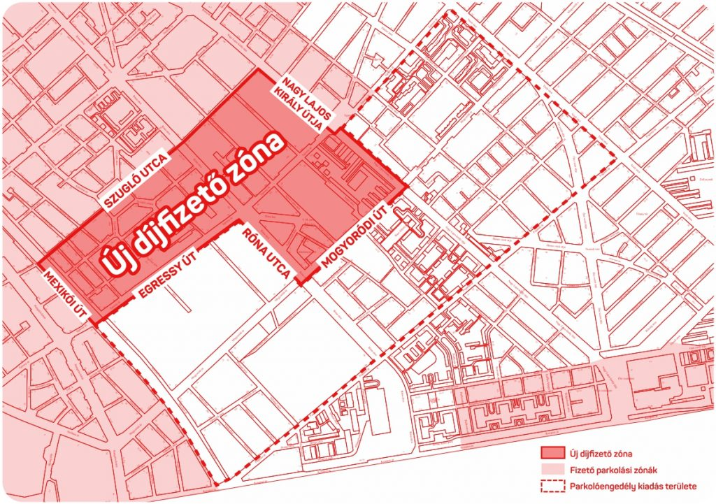



**Budapest, 2022. november 24.**